Guide for Parents on the Social Networks Children Use.
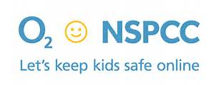

The NSPCC and O2 have produced a guide to help parents know how to keep their children safe online. They wanted to develop a guide, primarily aimed at parents of 8-12 year olds, about the social networks, apps or games with an interactive element that children use most frequently.
The purpose of the guide is to provide parents with the information they need to understand their child's online world and help them keep their children safe online.
We hope that Net Aware can help give parents the confidence to have balanced and informed conversations about what their children are doing online. The Guide can be found at the link below.
http://www.net-aware.org.uk/

