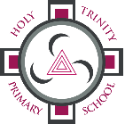

Online Learning Access For Holy Trinity Children
Communication
We will communicate updates through the school website, Twitter and Seesaw. Children will be able to access online activities through C2k MySchool, Education City, Bug Club and Seesaw.
C2k MySchool

The link for the C2k MySchool login is on the school website HomePage http://www.holytrinitybelfast.co.uk
It can also be found at www.c2kschools.net
Your child’s username will be their C2k login e.g. asmith123
If a child does not know their passwords, please contact their class teacher through Seesaw.
Fronter
We are using the computer-based virtual learning environment (VLE) called Fronter run by C2K. The advantage of online learning means that it can be accessed at any time, from any computer with internet access in the world.
Fronter is a learning platform which supports learning & teaching, collaboration & communication. Teachers can support children with regular News and resources for learning. Every teacher from P3-P7 has their own Fronter classroom which their class can access.
Fronter can be found by logging into C2k My School and going to My Links.
C2k NewsDesk (Access through C2kMy School-My Links)
The C2k NewsDesk is great for exciting and interesting stories. There is the NewsBank Section, News In Pictures and News in Video. Your child can also post comments and take part in the School Reporter. P4-P7 When on ‘School Reporter’ scroll down and click ‘Create a Front Page Story’ or ‘Create a Headline Story.’
Useful Websites
BBC Bitesize P1 and P2 https://www.bbc.co.uk/bitesize/levels/znyh7nb
BBC Bitesize P3 and P4 https://www.bbc.co.uk/bitesize/levels/z3g4d2p
BBC Bitesize P5-P7 https://www.bbc.co.uk/bitesize/levels/zjmj92p
Primary Homework Help http://www.primaryhomeworkhelp.co.uk/
Hour of Code https://hourofcode.com/uk/learn
Top Marks P1-P3 Maths https://www.topmarks.co.uk/maths-games/5-7-years/counting
Top Marks P4-P7 Maths https://www.topmarks.co.uk/maths-games/7-11-years/ordering-and-sequencing-numbers
Top Marks P1-P3 English https://www.topmarks.co.uk/english-games/5-7-years/letters-and-sounds
Top Marks P4-P7 Maths https://www.topmarks.co.uk/english-games/7-11-years/spelling-and-grammar
Early Years Pack: https://resource-bank.scholastic.co.uk/resources/439122 …
Key Stage 1 Pack: https://resource-bank.scholastic.co.uk/resources/439121 …
Lower Key Stage 2 Pack: https://resource-bank.scholastic.co.uk/resources/439120 …
Upper Key Stage 2 Pack: https://resource-bank.scholastic.co.uk/resources/439108 …

Code.org Code Break
Khan Academy
Free Twinkl for a month
The ‘Parents Hub’ section has lots of online educational games, eBooks and Homework Help.
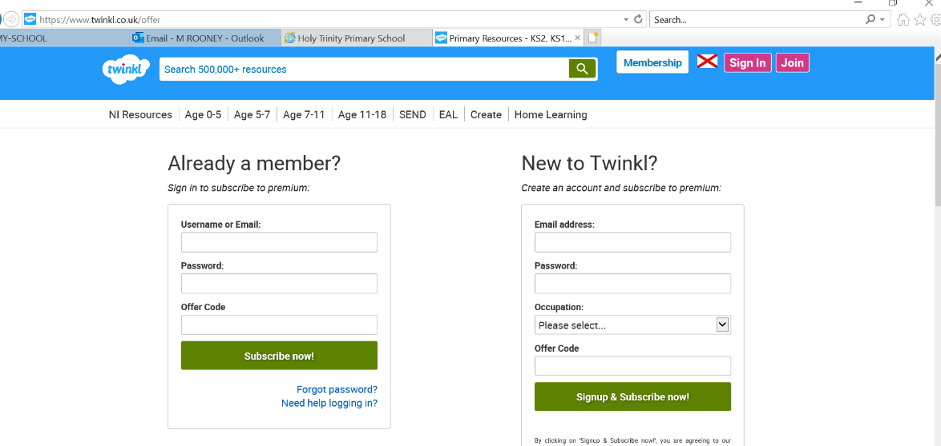
https://www.twinkl.co.uk/offer

The offer code is: UKTWINKLHELPS
This will give you free access for one month.
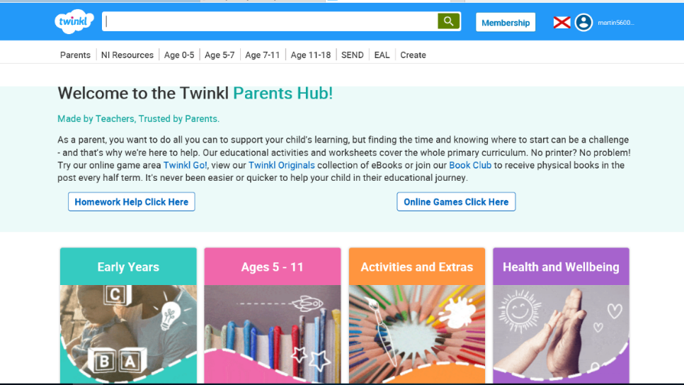
Go to the Parents Tab

Click below for Padlet School Closure Survival Kit https://padlet.com/green_margaretm/544cgn0fzrg4
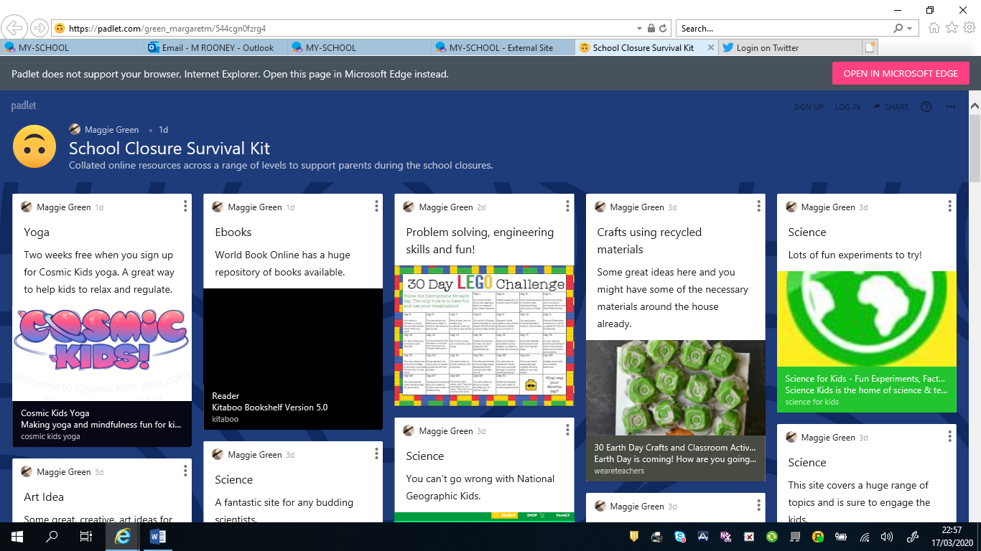

To change your C2k Password
https://services.c2kni.net/ums/

