Dear Parents and Guardians,
As you are aware the coronavirus is on the increase in Northern Ireland and we want to be proactive to reduce the risk to our pupils, staff and community.
With that in mind, we will share the following video with our children in class and reinforce with them the importance of good hygiene including proper handwashing techniques.
BBC Video
https://www.bbc.co.uk/news/av/health-51754472/coronavirus-how-to-wash-your-hands-in-20-seconds
We have had a number of updates from the Department of Education regarding Coronavirus.
The simple message seems to stress the importance of personal hygiene, all of us ensuring that we wash our hands and that we use tissues.
I have included the link to the Public Health Agency advice, this is being updated regularly.
https://www.publichealth.hscni.net/news/covid-19-coronavirus
It gives information and advice regarding Coronavirus.

Like seasonal flu, the same public health advice applies for COVID-19 (Coronavirus): if you cough or sneeze, use a tissue to cover your mouth and nose, throw it away carefully after use, and wash your hands.
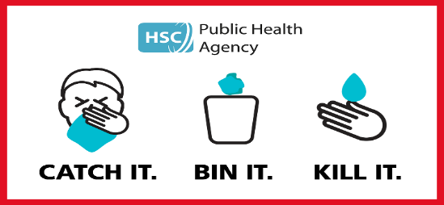
Once flu and similar infectious viruses begin to spread, the main method that can prevent further spread, is good personal hygiene. Washing your hands regularly will help prevent flu and other viruses spreading. Here is a link to the NHS guidance and a CBBC video on proper hand washing which our older children and indeed all adults may find beneficial.
https://www.nhs.uk/live-well/healthy-body/best-way-to-wash-your-hands/
https://www.bbc.co.uk/newsround/51342366
We will continue to monitor the advice and guidance from the Department of Education and the Public Health Agency and inform you of any further updates. We would ask parents to inform Mrs Boyd of any confirmed coronavirus cases within their family. We hope everyone remains safe.
Thank you
Mrs F Boyd

